Project Report

**Project Title: QUADCOPTER DRONE**.

Md. Juwel Rana (IT-14052)

Md. Asaduzzaman (IT-14053)

Md. Yasin Arafat (IT-13049)

Dept of ICT, MBSTU

ABSTRACT

Quadcopter can achieve vertical flight in a stable manner and be used to monitor or collect data in a specific region such as mapping terrains. Technological advances have reduced the cost and increase the performance of the low power microcontrollers that allowed the general public to develop their own Quadcopter.

The goal of this project is to build, modify, and make improvements in Quadcopter design to obtain stable flight, gather and store CO2 data. It can also be used as agricultural purposes.

The final Quadcopter design had to meet the following specifications:

1. The Quadcopter must be capable of flying and landing in stable manner.
2. The Quadcopter must be capable of determining its current location using GSM data.
3. The Quadcopter must be capable to storing and logging data.
4. The Quadcopter must be able to perform the following commands:

* Auto-landing
* Auto-move
* Auto-homing

Calibration and tuning of the PID controller was done to obtain proper stabilization on each axis using custom PID test benches. Currently, the Quadcopter can properly stabilize itself, determine its location. This report also described the auto-commands, and live video streaming that can be implementing at a later stage. Most of the goals in this project have been achieved, resulting in a stable and maneuverable Quadcopter.

**Instruments:**

* Frame
* Brushless motor-1100kv and Propeller.
* Electronic speed controllers (ESC-30A).
* Arduino development board or flight controller (SP racing F3).
* and sensor boards
* Batteries
* Transmitter and receiver- 6 channels.
* GPS module.
* Battery and Charger.
* Hold position.

**Configuration:**

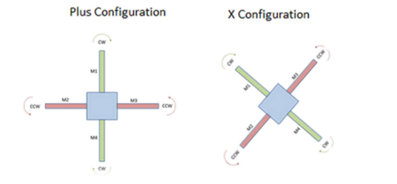

**Fig:** Basic configuration of a Quadcopter.

**Block Diagram:**

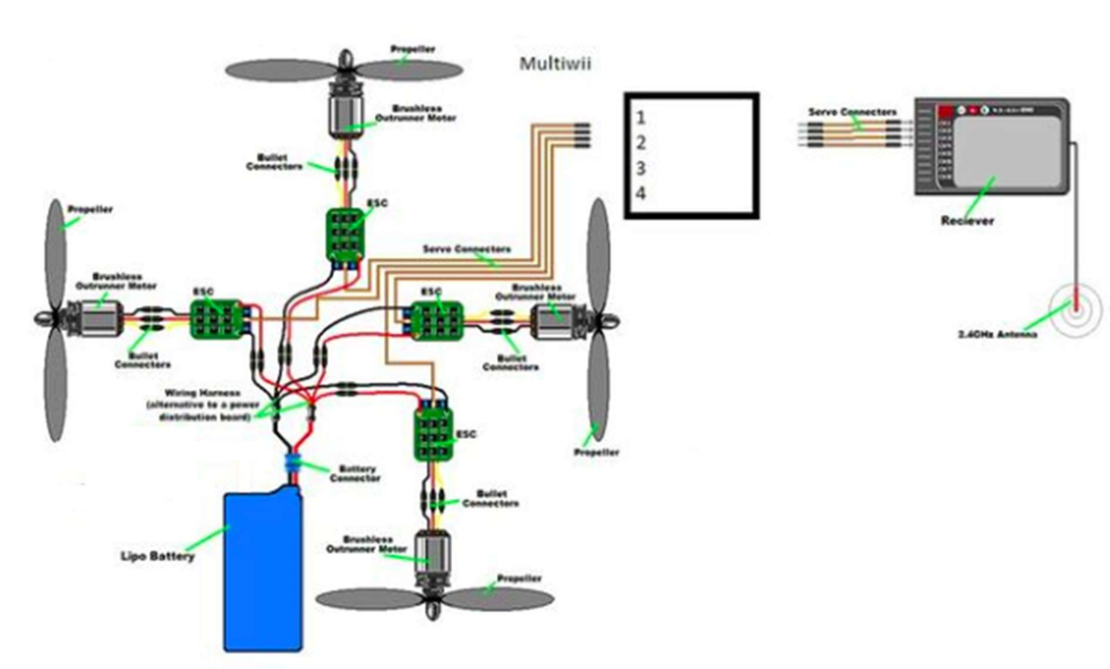

**System Overview:**

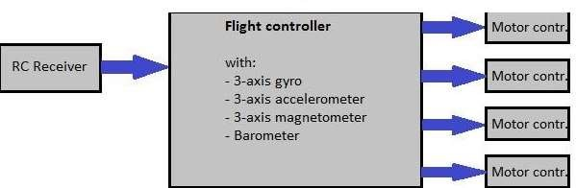

**Controls :**

**Roll** – Done by pushing the right stick to the left or right. Literally rolls the quadcopter, which maneuvers the quadcopter left or right.

**Pitch** – Done by pushing the right stick forwards or backwards. Tilts the quadcopter, which maneuvers the quadcopter forwards or backwards.

**Yaw** – Done by pushing the left stick to the left or to the right. Rotates the quadcopter left or right. Points the front of the copter different directions and helps with changing directions while flying.

**Throttle** – Engaged by pushing the left stick forwards. Disengaged by pulling the left stick backwards. This adjusts the altitude, or height, of the quadcopter.

**Trim** – Buttons on the remote control that help you adjust roll, pitch, yaw, and throttle if they are off balance.

**Rudder** – You might hear this term thrown around, but it’s the same as the left stick. However, it relates directly to controlling yaw (as opposed to the throttle).

**Aileron** – Same as the right stick. However, it relates directly to controlling roll (left and right movement).

**Elevator** – Same as the right stick. However, it relates directly to controlling pitch (forwards and backwards movement).

Maneuvering:

**Bank turn** – A consistent circular turn in either the clockwise or counterclockwise direction.

**Hovering** – Staying in the same position while airborne. Done by controlling the throttle. Roll

Roll moves your quadcopter left or right. It’s done by pushing the right stick on your transmitter to the left or to the right.

**Pitch**- Pitch is done by pushing the right stick on your transmitter forwards or backwards. This will

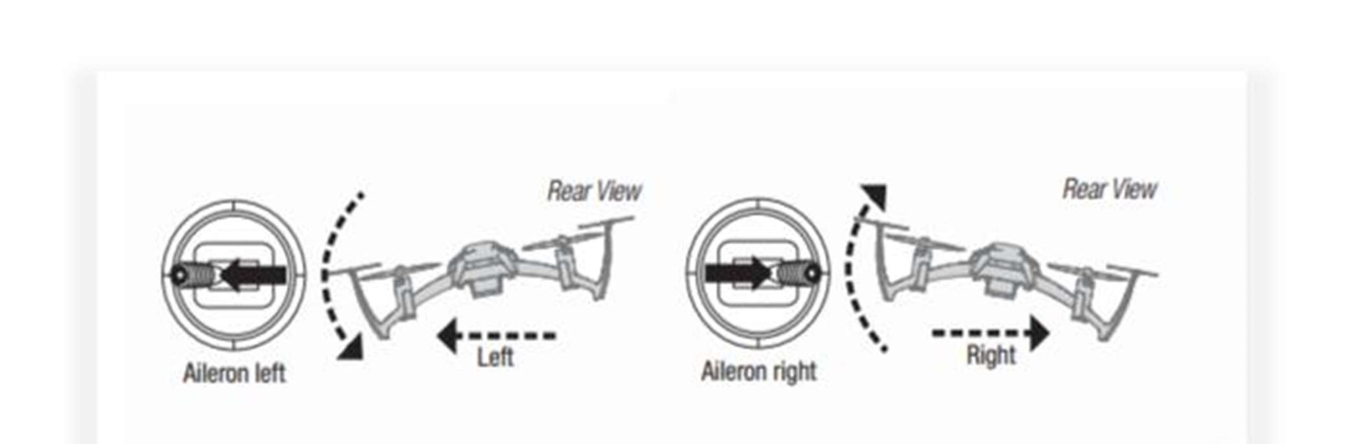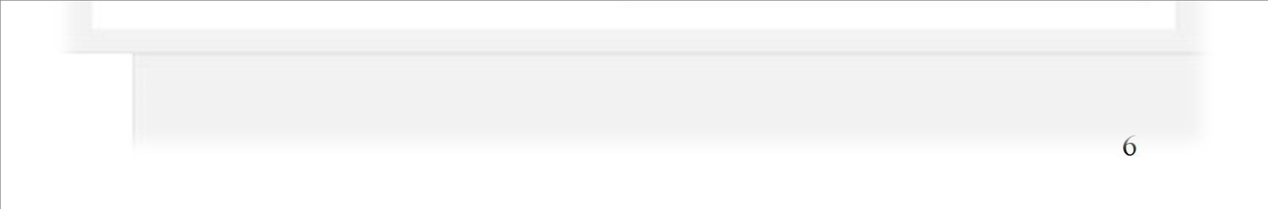

Figure 1.4 Example of a quadcopter rolling left and right. Notice the tilt of the quadcopter

Pitch

tilt the quadcopter, resulting in forwards or backwards movement.

Figure 1.5 Example of a quadcopter pitching forwards and backwards

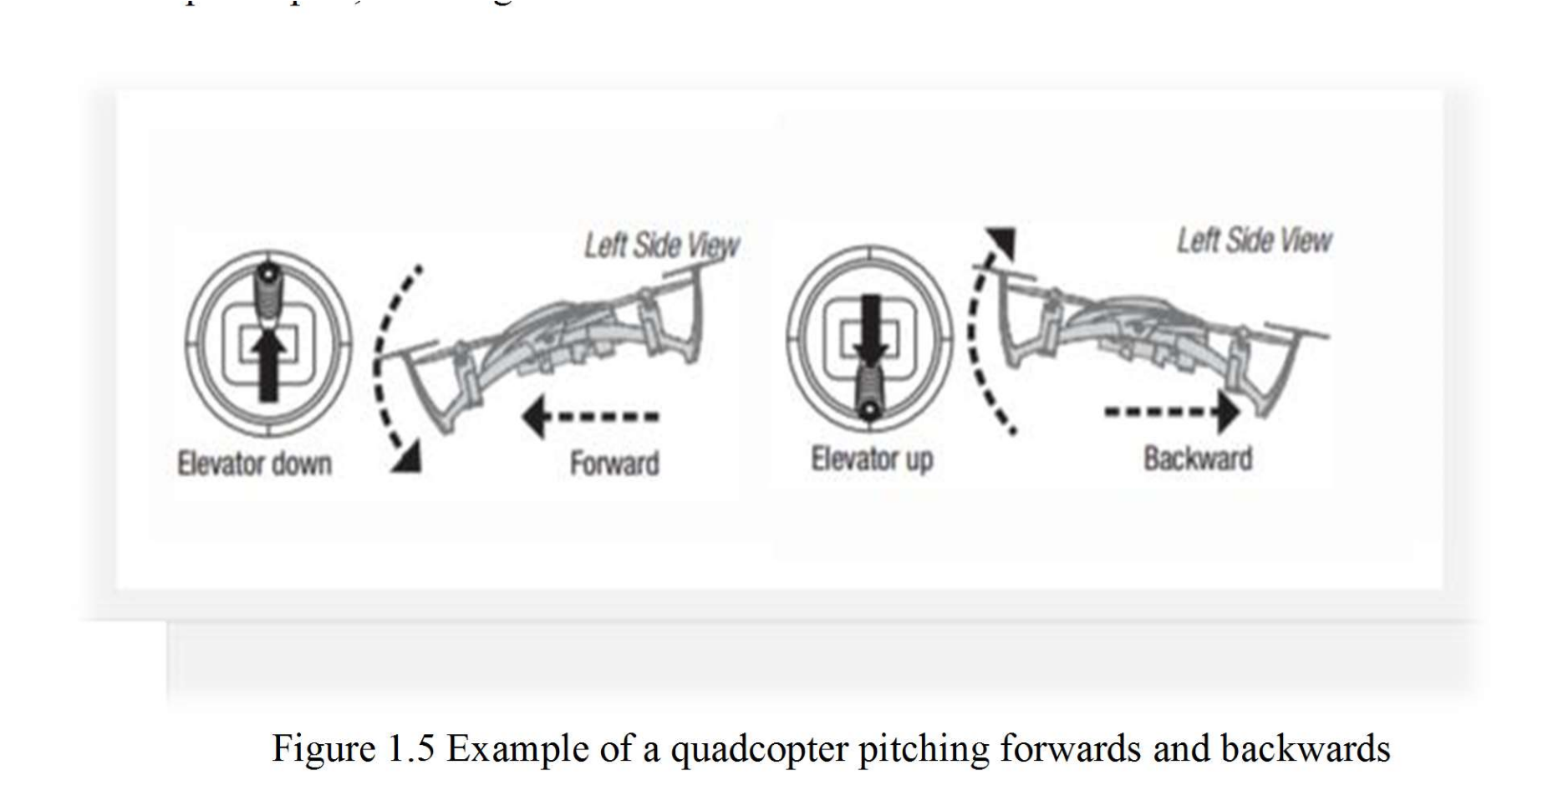

**Yaw**-This is done by pushing the left stick to left or to the right.

**Throttle-**Throttle gives the propellers on your quadcopter enough power to get airborne. When flying, you will have the throttle engaged constantly. To engage the throttle, push the left stick

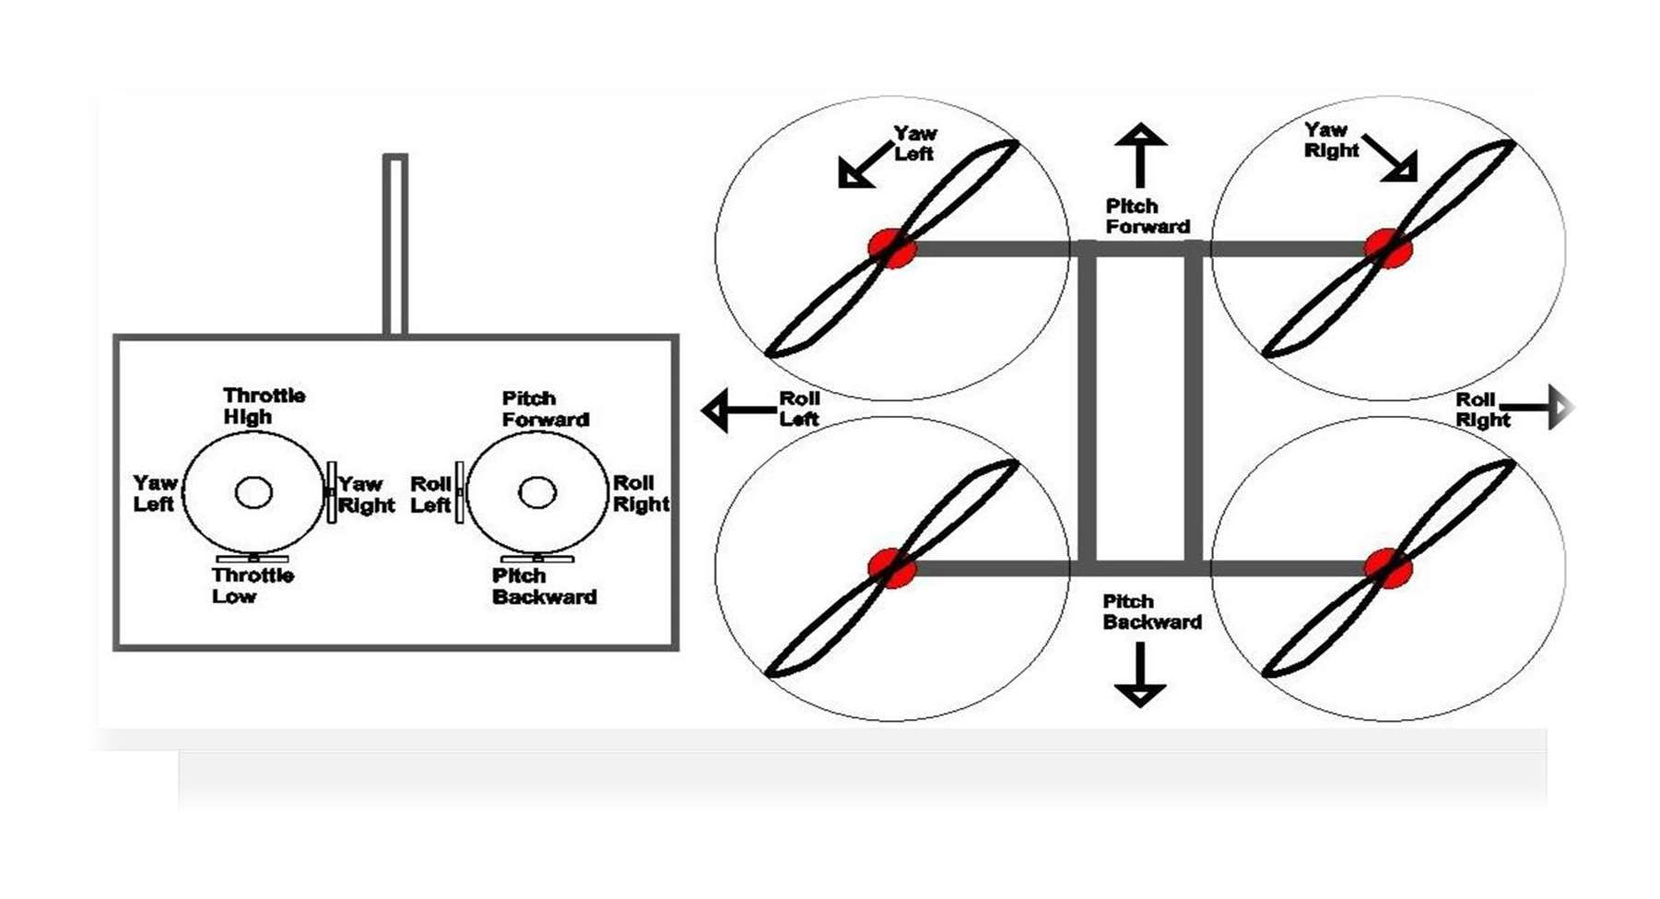

forwards. To disengage, pull it backwards.

Figure 1.6 Simple sketch of roll, pitch, yaw, and throttle on a transmitter (left image) and

quadcopter (right image).

**Working Principle:**

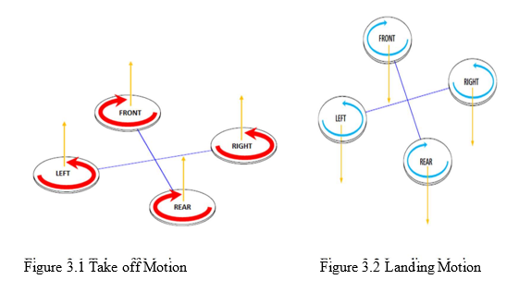

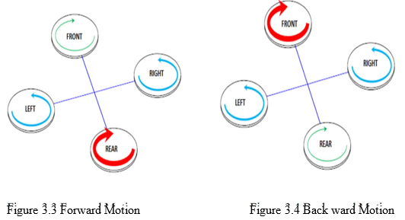

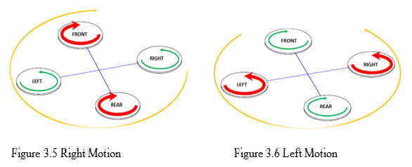

* At first we have to connect the BLDC motor with ESC.
* Connect the ESC battery elimination circuit with the flight controller in corresponding pin.
* Configure the SP Racing F3 with configurator software.
* Connect the flight controller with the receiver.
* Bind the receiver with the Transmitter.

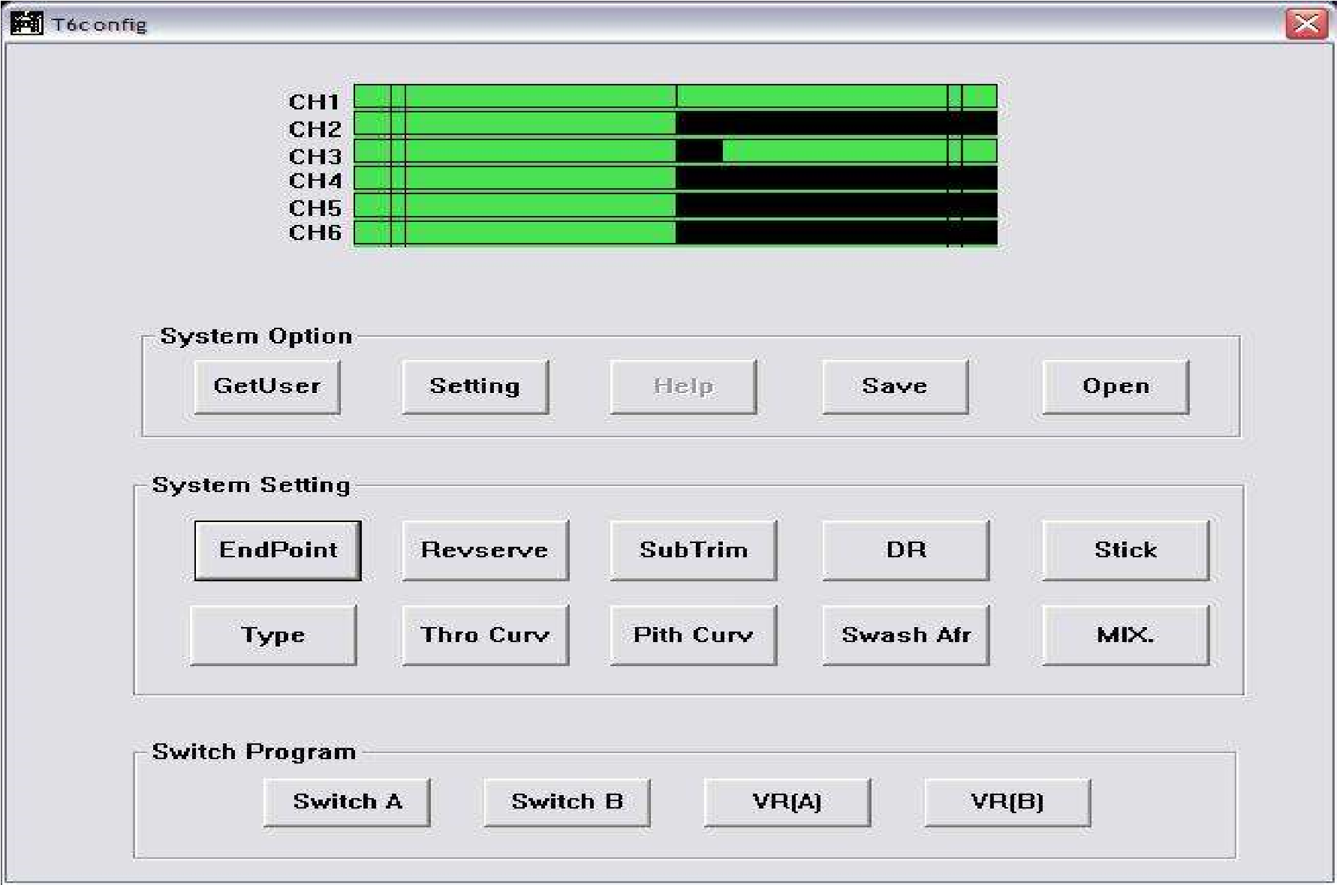

**Figure:** Transmitter configurator.

**Future Implementation:**

(a) In future, we will upgrade this robot with FPV and GPS system.

(b) We also can upgrade this robot as a Aerial photography.

**References:**  
(1) www.google.com , www.instructables.com , www.youtube.com.  
(2) Robot building for beginners –David Cook.